LEARNING AND DEVELOPMENT MANAGEMENT FUNCTIONS
SUMMATIVE ASSESSMENTS

Module # | 242401001-KM-02
NQF Level | 5
Notional hours | 80
Credit(s) | 8
Development  Quality Partner | ETDP SETA
Occupation or Specialization | 242401001;Learning and Development Practitioner
Associated Occupation | 242401001;Learning and Development Practitioner

Name
Contact Address
Telephone (H)
Telephone (W)
Facsimile
Cellular
E-mail

Note to the learner
This Learner Guide provides a comprehensive overview of the module. It is designed to improve the skills and knowledge of learners, and thus enabling them to effectively and efficiently complete specific tasks.
Purpose
The main focus of the learning in this knowledge module is to build an understanding of concepts required to manage learning and development.
Topic elements to be covered include
- KM-02-KT01: Learning and development management concepts (15%)
- KM-02-KT02: Learning and development intervention planning and co-ordination (20%)
- KM-02-KT03: Learning and development quality management concepts (30%)
- KM-02-KT04: Learning and development procurement concepts and practices (10%)
- KM-02-KT05: Communication and reporting within Learning and Development Management (15%)
- KM-02-KT06: Learning and development ethics (10%)
Exemptions
No exemptions are currently recognised for any of the listed knowledge modules. An RPL approach is recommended for all listed knowledge modules
Entry Requirements
NQF level 4 with Communication
Provider Accreditation Requirements for the Knowledge Module
Physical Requirements
- Learning and development resources aligned to the scope and content of the module
- Learner assessment resources (database, tools, records)

Human Resource Requirements:
- Access to facilitators of learning with subject matter expertise as evident from professional designations, or experiential competence or prior qualifications
- Access to assessment expertise in terms of subject matter related prior learning, experience and credibility
Legal Requirements
- Access to facilities that comply with occupational health and safety standards where contact learning or assessment sessions are delivered
Venue, Date and Time:
Consult your facilitator should there be any changes to the venue, date and/or time.
Refer to your timetable
Assessments
The only way to establish whether you are competent and have accomplished the learning outcomes is through continuous assessments. This assessment process involves interpreting evidence about your ability to perform certain tasks. You will be required to perform certain procedures and tasks during the training programmer and will be assessed on them to certify your competence.

This module includes assessments in the form of self-evaluations/activities and exercises. The exercises, activities and self-assessments will be done in pairs, groups or on your own. These exercises/activities or self-assessments (Learner workbook) must be handed to the facilitator. It will be added to your portfolio of evidence, which will be proof signed by your facilitator that you have successfully performed these tasks.

Listen carefully to the instructions of the facilitator and do the given activities in the time given to you.

  Books | This icon means that other books are available for further information on a particular topic/subject.
  References | This icon refers to any examples, handouts, checklists, etc…
  Important | This icon represents important information related to a specific topic or section of the guide.
  Activities | This icon helps you to be prepared for the learning to follow or assist you to demonstrate understanding of module content. Shows transference of knowledge and skill.
  Exercises | This icon represents any exercise to be completed on a specific topic at home by you or in a group.
  Tasks/Projects | An important aspect of the assessment process is proof of competence. This can be achieved by observation or a portfolio of evidence should be submitted in this regard.
  Workplace Activities | An important aspect of learning is through workplace experience. Activities with this icon can only be completed once a learner is in the workplace
  Tips | This icon indicates practical tips you can adopt in the future.
  Notes | This icon represents important notes you must remember as part of the learning process.

KM-02-KT01: Learning and development management concepts

KT0101 | Functions of management (Plan, lead, organise and control)
KT0102 | Cost control and budgeting (Principles, processes and procedures)
KT0103 | Workforce development planning concepts (Job design, Job evaluation, Competency profiles)
KT0104 | Personal development concepts (performance management, talent management, ethics management)
KT0105 | Lifelong learning and continuous professional development concepts

ACTIVITY
1

Describe the diagram below
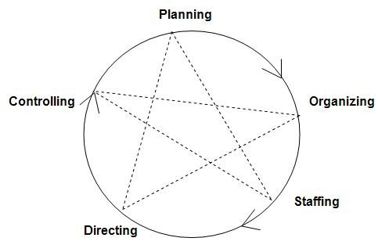

________________________________________________________________________________________________________________________________________________________________________________________________________________________________________________________________________________________________________________________________________________________________________________________________________________________________________________________________________________________________________________________________________________________________________________________________________________________________________________________________________________________________________________________________________________________________________________________________________________________________________________________________________________________________________________________________________________________________________
______________________________________________________________________________________________________________________________________________________________________________________________________________________________________________________________________________________________________________________________________________________________________________________________________
________________________________________________________________________________________________________________________________________________________________________________________________________________________________________________________________________________________________________________________________________________________________________________________________________________________________________________________________________________________________________________________________________________________________________________________________________________________________________________________________________________________________________________________________________________________________________________________________________________________________________________________________________________________________________________________________________________________________________

KM-02-KT02: Learning and development intervention planning and co-ordination

KT0201 | Intervention planning and coordination concepts (planning, designing, administering and co-ordinating of an intervention pertaining to logistics, intervention costs, venues)

ACTIVITY
2

Express the on Plan & Implement Interventions
________________________________________________________________________________________________________________________________________________________________________________________________________________________________________________________________________________________________________________________________________________________________________________________________________________________________________________________________________________________________________________________________________________________________________________________________________________________________________________________________________________________________________________________________________________________________________________________________________________________________________________________________________________________________________________________________________________________________________
______________________________________________________________________________________________________________________________________________________________________________________________________________________________________________________________________________________________________________________________________________________________________________________________________
KM-02-KT03: Learning and development quality management concepts

KT0301 | Quality assurance in a learning and development environment
KT0302 | Quality control, compliance, implementation and evaluation
KT0303 | Quality review
KT0304 | Best practice standards (Learning and Development and Workplace)

ACTIVITY
3

Discuss the quality assurance in a learning and development environment
________________________________________________________________________________________________________________________________________________________________________________________________________________________________________________________________________________________________________________________________________________________________________________________________________________________________________________________________________________________________________________________________________________________________________________________________________________________________________________________________________________________________________________________________________________________________________________________________________________________________________________________________________________________________________________________________________________________________________
______________________________________________________________________________________________________________________________________________________________________________________________________________________________________________________________________________________________________________________________________________________________________________________________________
KM-02-KT04: Learning and development procurement concepts and practices

KT0401 | The process of advertising and sourcing
KT0402 | Best procurement processes and practices (PFMA, vendor registration and supplier vetting, tendering)
KT0403 | Contractual agreements (SLA, MOU, Joint Ventures, and other forms of agreements/contracts)
KT0404 | B-BBEE enterprise and supplier development provisions

ACTIVITY
4

Describe the flowchart below
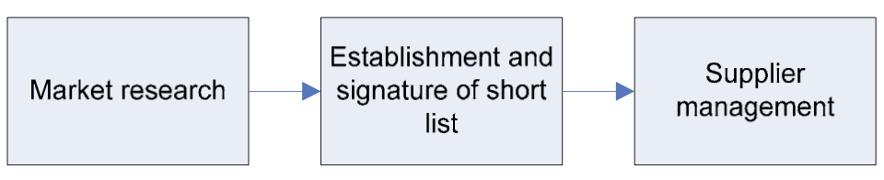

__________________________________________________________________________________________________________________________________________________________________________________________________________________________________________________________________________________________________________________________________________________________________________________________________________________________________________________________________________________________________________________________________________________________________________________________________________________________________________________________________________________________________________________________________________________________________________________________________________________________________________________________________________________________
KM-02-KT05: Communication and reporting within Learning and Development Management

KT0501 | Communication principles, concepts and practices
KT0502 | Report writing and presentation concepts
KT0503 | Stakeholder communication and relationship management (consultative processes, buy-in, respect, rapport building, negotiation, diversity and conflict)
KT0504 | Dialogue and conversations (perceptions, values, personal motivation, target audience)
KT0505 | Group dynamics (identify groups, understand groups, communication types applicable to different groups)
IAC0501 | Effective communication practices are identified for various learning and development management scenarios, contexts and applications

ACTIVITY
5

Show the process of report writing
____________________________________________________________________________________________________________________________________________________________________________________________________________________________________________________________________________________________________________________________________________________________________________________________________________________________________________________________________________________________________________________________________________________________________________________________________________________________________________________________________________________________________________________________________________________________________________________________________________

KM-02-KT06: Learning and development ethics

KT0601 | Organizational and professional ethical practices and concepts
KT0602 | Ethics in professional learning and development practice and reporting
KT0603 | Ethical business values and codes of conduct

ACTIVITY
6

Discuss the concept of organizational and professional ethical practices and concepts
________________________________________________________________________________________________________________________________________________________________________________________________________________________________________________________________________________________________________________________________________________________________________________________________________________________________________________________________________________________________________________________________________________________________________________________________________________________________________________________________________________________________________________________________________________________________________________________________________________________________________________________________________________________________________________________________________________________________________
____________________________________________________________________________________________________________________________________________________________________________________________________________________________________________________________________________________________________________________________________________________________________________________________________________________________________________________________________________________

Competent(Tick/Cross) Not Yet Competent(Tick/Cross)
Action/s required (if any):

By when:
Learner Feedback & Comments
Declaration by the Learner
I ……………………………………………………………………………….. the candidate, declare that I have received feedback and been informed of my overall competence for the criteria within the assignment.
Declaration by the Assessor
I ……………………………………………............. (Assessor) hereby certify that I have examined the learner workbook and I am satisfied with the Facilitator Judgment of this assessment.

Learner (Sign) | Date | Assessor (Sign) | Date
Moderator (Sign) |  |  | Date

